**Project 1:**

**Information Gathering and Exploitation**

**Task 1:** Take some random websites using Google hacking database and enter into their admin panel using SQL Injections (Manual and using a tool called burp suite)  
**Task 2:**Show some live cameras using Google hacking database.

SOLUTION:

TASK:

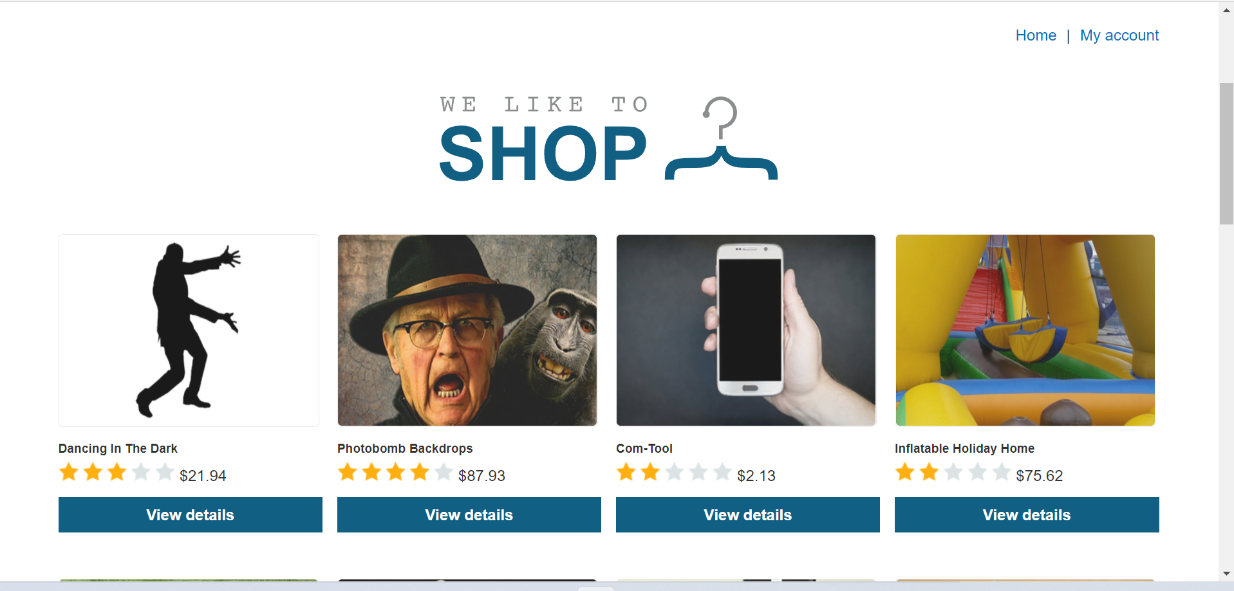

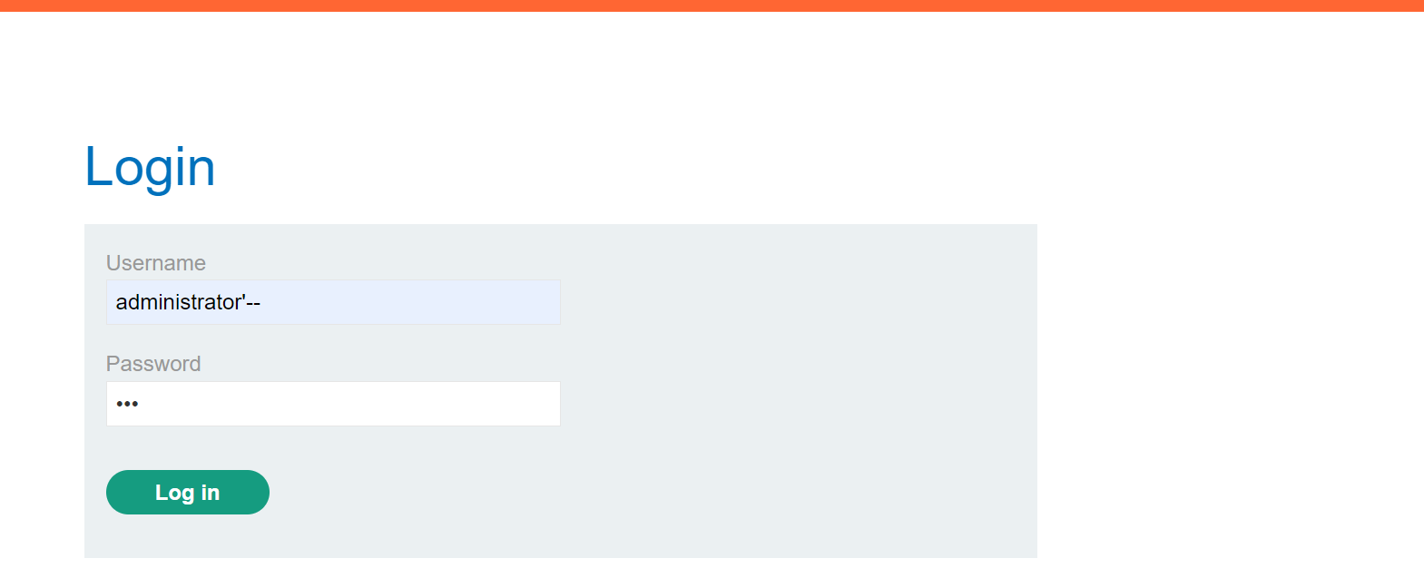

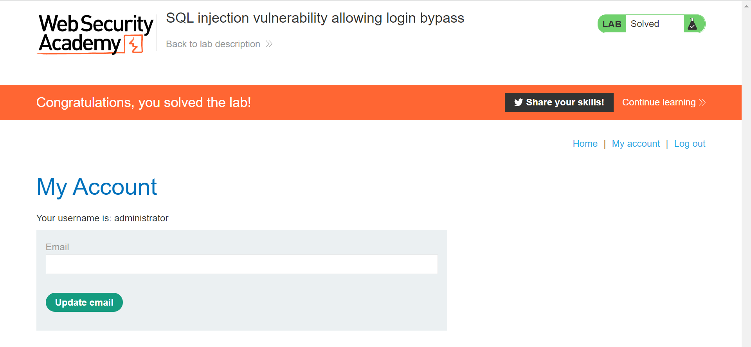

2. task 2:

